1st circular

Faculty of Science, Charles University
and
Czech Association of Geomorphologists
warmly invite you to the 17th annual conference


State of geomorphological research in 2017
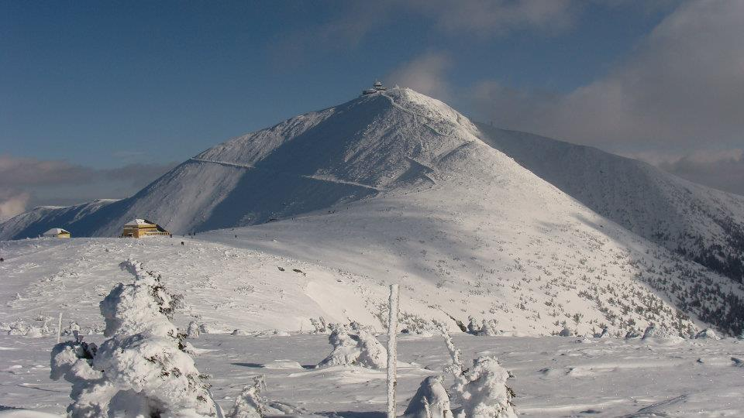

The conference will take place in the Pec pod Sněžkou on 17. ‐ 19. May 2017

Dear colleagues,
We would like to invite you to the 17th annual Conference of the Czech Association of Geomorphologists „State of geomorphological researches in 2017”, which is organized by the Faculty of Science, Charles University. The conference venue is situated in the highest mountain range of Czech Republic. We welcome contributions from the field of geomorphology and related disciplines focusing on landscape evolution and it’s forming processes. We hope that the conference will be pleasant and inspiring event for you, also thanks to the post‐conference field trip which will be dedicated to glacial and periglacial phenomena.

Preliminary program
Wednesday 17. 5. 2017
9:00 – 13:00 participant registration
13:00 conference opening
13:15 invited lectures
15:30 lectures in sessions
20:00 meeting of the Czech Association of Geomorphologists

Thursday 18. 5. 2017
8:30 – 18:00 lectures in sessions
19:00 + closing ceremony, closing diner

Friday 19. 5. 2017
8:00 – 17:00 field trip

Prices: Conference fee (incl. VAT)
Full price 1800 CZK (70 EUR)
Discounted price1) 1600 CZK (60 EUR)
Student price2) 1100 CZK (42 EUR)
1) For members of Czech Association of Geomorphologists;
2) Student rates apply to fulltime students only, valid proof of student status required

Deadlines
10. 3. 2017 Deadline for abstract submission and registration
31 .3. 2017 Deadline for the payment of registration fee (accommodation for 2 nights, full board, conference and excursion fees). The bank account will be announced in the Second Circular.

Registration and abstract writing instructions:
Application must include: 1) name; 2) poster or oral presentation; and 3) interest in the field trip (see in attachment). Abstracts must be written in English (max. 250 words, no graphics and no references) and sent with the application to the contact e-mail cag2017@seznam.cz no later than on 10th March.

Organizing committee
V. Vílímek,
M. Křížek,
Z. Engel,
M. Kusák,
A. Emmer

Contact:
M. Kusák cag2017@seznam.cz

Further information

Conference venue:

Horská chata Univerzity Karlovy v Peci pod Sněžkou
http://www.cuni.cz/UK-5199.html

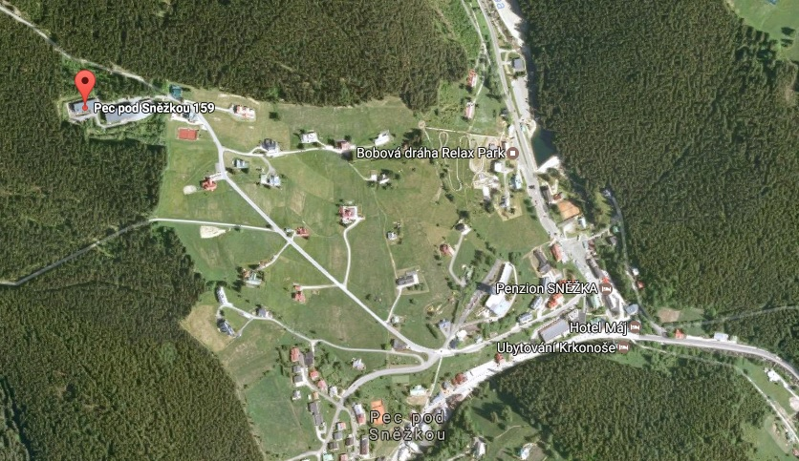

Attachment

REGISTRATION
State of geomorphological research in 2017

1. participant informations
Name and surname
Affiliation
Address
E-mail
Phone number

2. PRESENTATION
Title of presentation
Type of presentation | Oral | Poster
Authors

3. Field trip
Interest in the field trip | YES | NO

